**Project Design Phase-II**

**Data Flow Diagram & User Stories**

|  |  |
| --- | --- |
| Date | 9 APRIL 2025 |
| Team ID | SWTID1743254297 |
| Project Name | TUNETRAIL- YOUR PATHWAY TO PERFECT PLAYLIST |
| Maximum Marks | 4 Marks |

**3.3 Data Flow Diagram (DFD)**

**Level 0**

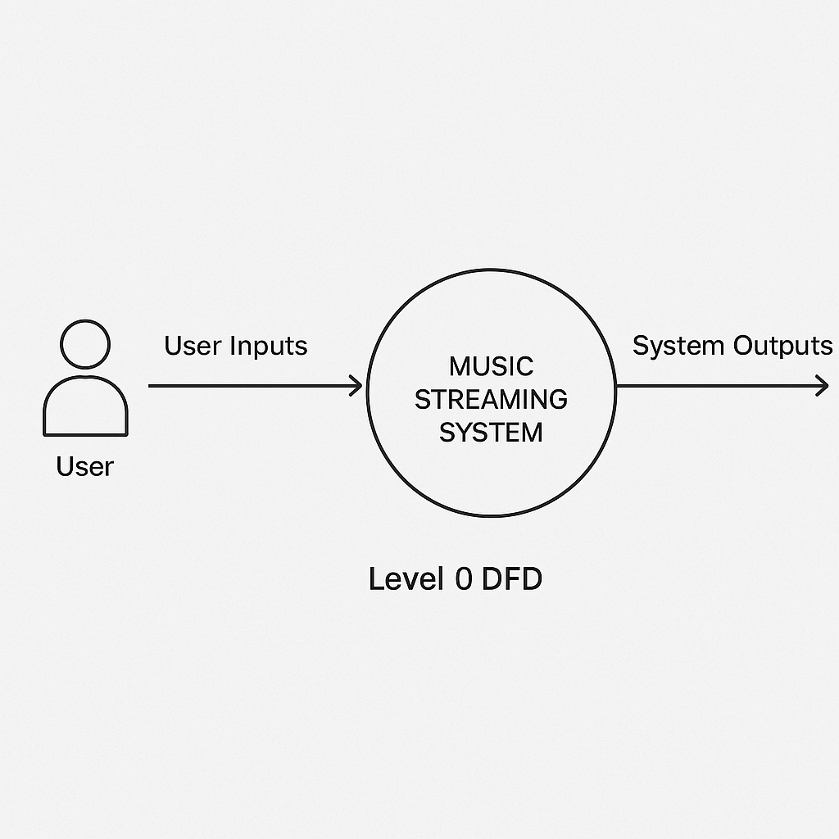

**LEVEL 1**

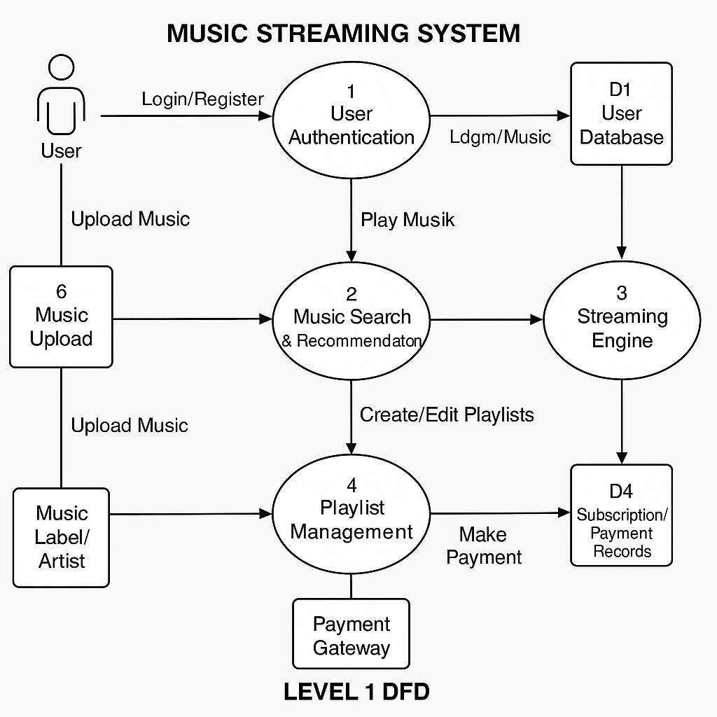

**CUSTOMER JOURNEY MAP**

